**Consider the following schema for Order Database:**

**SALESMAN (*Salesman_id, Name, City, Commission*)**

**CUSTOMER (*Customer_id, Cust_Name, City, Grade, Salesman_id*)**

**ORDERS (*Ord_No, Purchase_Amt, Ord_Date, Customer_id, salesman_id*)**

**Draw the conceptual schema. Write SQL queries to**

1. **Count the customers with grades above Bangalore’s average.**
2. **Find the name and numbers of all salesmen who had more than one customer.**
3. **List all salesmen and indicate those who have and don’t have customers in their cities**

**(Use UNION operation.)**

1. **Create a view that finds the salesman who has the customer with the highest order of a day.**
2. **Demonstrate the DELETE operation by removing salesman with id 1000. All his orders must also be deleted.**

**Conceptual Schema**

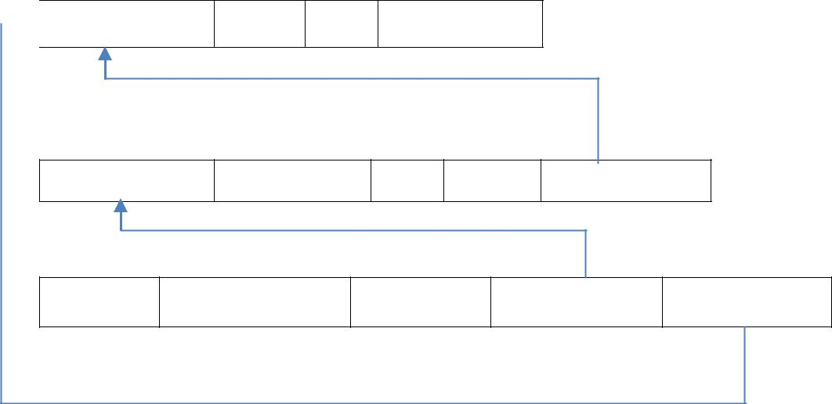

***Salesman_id*** *Name City* *Commission*

***Customer***

***Customer_id*** *Cust_Name City Grade Salesman_id*

***Orders***

***Ord_No*** *Purchase_Amt Ord_Date Customer_id* *Salesman_id*

1. **Count the customers with grades above Bangalore’s average.**

SELECT GRADE, COUNT (DISTINCT CUSTOMER_ID) FROM CUSTOMER1

GROUP BY GRADE

HAVING GRADE > (SELECT AVG(GRADE) FROM CUSTOMER1

WHERE CITY='BANGALORE');

1. **Find the name and numbers of all salesmen who had more than one customer.**

SELECT SALESMAN_ID, NAME FROM SALESMAN A

WHERE 1 < (SELECT COUNT (*)

FROM CUSTOMER1

WHERE SALESMAN_ID=A.SALESMAN_ID);

1. **List all salesmen and indicate those who have and don’t have customers in their cities (Use UNION operation.)**

SELECT SALESMAN.SALESMAN_ID, NAME, CUST_NAME, COMMISSION FROM SALESMAN, CUSTOMER1

WHERE SALESMAN.CITY = CUSTOMER1.CITY UNION

SELECT SALESMAN_ID, NAME, 'NO MATCH', COMMISSION FROM SALESMAN

WHERE NOT CITY = ANY (SELECT CITY

FROM CUSTOMER1) ORDER BY 2 DESC;

1. **Create a view that finds the salesman who has the customer with the highest order of a day.**

CREATE VIEW ELITSALESMAN AS

SELECT B.ORD_DATE, A.SALESMAN_ID, A.NAME FROM SALESMAN A, ORDERS B

WHERE A.SALESMAN_ID = B.SALESMAN_ID

AND B.PURCHASE_AMT=(SELECT MAX (PURCHASE_AMT)

FROM ORDERS C

WHERE C.ORD_DATE = B.ORD_DATE);

1. **Demonstrate the DELETE operation by removing salesman with id 1000. All his orders must also be deleted.**

Use ON DELETE CASCADE at the end of foreign key definitions while creating child table orders and then execute the following:

Use ON DELETE SET NULL at the end of foreign key definitions while creating child table customers and then executes the following:

DELETE FROM SALESMAN

WHERE SALESMAN_ID=1000;